**Black Friday**

**Problem:** Predict purchase amount.

**Description:**

This dataset contains of sales transactions collected at a retail store. It’s a classic dataset to explore and expand your feature engineering skills and day to day understanding from multiple shopping experiences.

The dataset has 550,069 rows and 12 columns.

**Variables Info:**

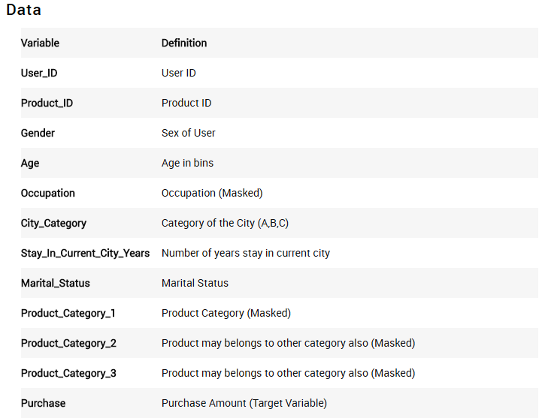

References:-

Kaggle.com

Note:

This Data Set is only for practice purpose, do not misuse it.